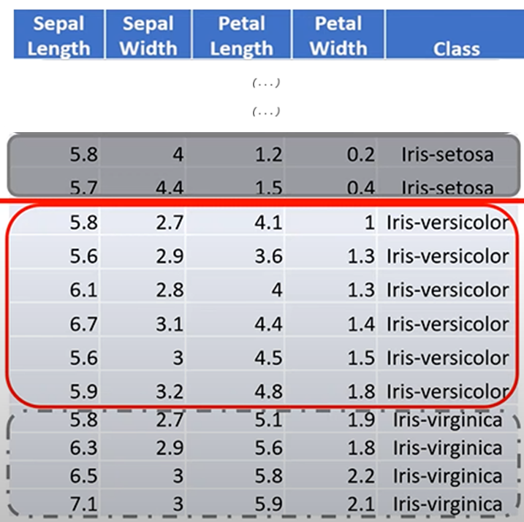

**2.**

**3.**

**4.**

**1.**

**5.**

**Mix of classes in split 1.**

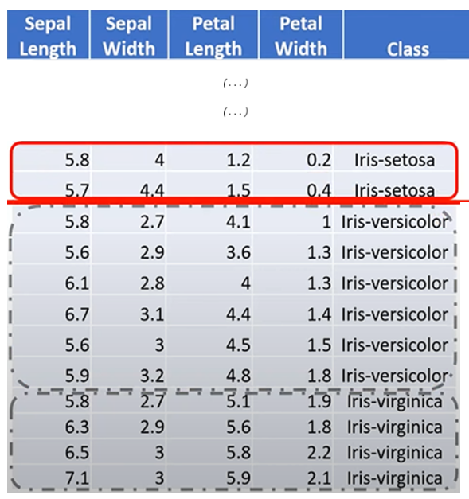

The white oval nodes represent a Feature.

Contains:

* The name of the Feature we are looking at.
* Keeps track of the size of the dataset at this exact point.
  + i.e. Keeps track of the number of observations I have.

